Survey report
  - Survey
A seventeen question online survey was launched September 18 - October 28, 2025. The survey was distributed in the following ways:
- Using the mailing list available to YNA – those RNs and NPs who had provided consent during their license application and / or renewal process.
- Reaching out to nursing leaders at each of the main employers
- Posting on the YNA Instagram
- Direct encouragement in lunch rooms / cafeteria / immunization clinics
Extra efforts were made to increase the responses by LPNs.
180 responses were received, which is approximately 25% of the nursing workforce resident in Yukon.

    - Information on respondents
Of the 170 respondents, 134 (79%) were RNs, 8 (5%) were Nurse Practitioners, and 28 (16%) were LPNs. No student nurses or Psychiatric nurses responded.
The majority of respondents were experienced nurses. Despite the recruitment efforts, and the understanding that the workforce in Yukon is increasingly junior, the survey did not attract those “new nurses.”
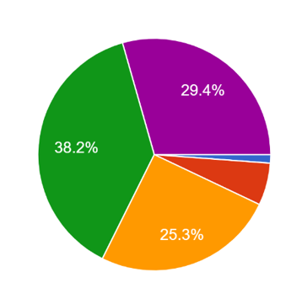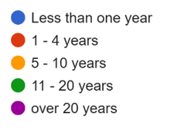
In understanding what type of employers and environments, there was good representation.
For employers: 35% are at the Whitehorse General Hospital, followed by 23% at Continuing Care and 16% in Community Nursing.
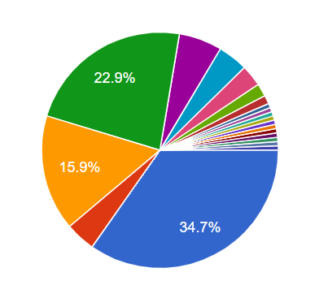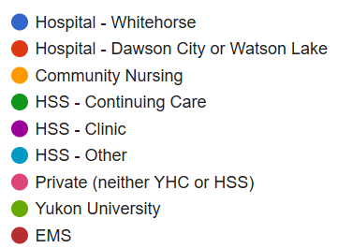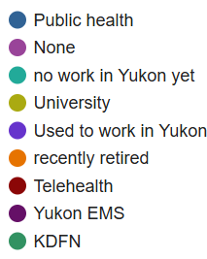
For environments: acute care and primary care each had 33% of total respondents. Other primary environments were public health, leadership and education / research with a number of unique single answers.
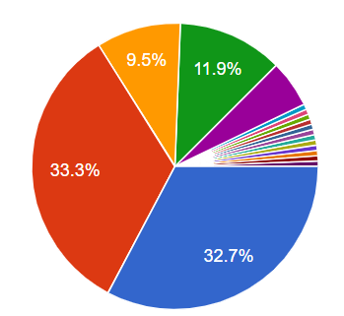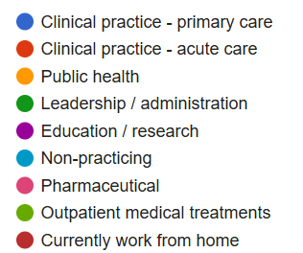

    - Insurance
One question was asked of LPNs and RPNs only, given their licensing does not include CNPS coverage as is the case for LPN and NPs. The question was whether they would consider purchasing professional liability insurance. Of the 28 respondents, 43% identified that they would like to purchase it and do not currently. 39% already purchase it themselves. Only one answered that they feel adequately covered by their employer. While some are purchasing insurance, there is a possible small market to educate and support LPNs in obtaining insurance.
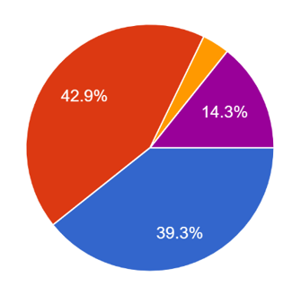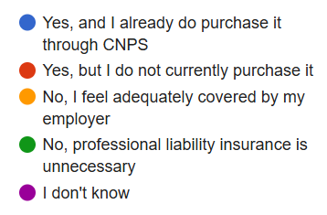

    - Priorities for YNA
Respondents were asked to identify the relative importance of a range of services typically offered by associations – in order to help inform the strategic priorities of the YNA. The following outlines the responses overall. Of note, advocacy – for both the nursing profession and to advance quality healthcare – was the most significant overall, followed by an interest in professional development offerings and then professional practice navigation.

This was further reinforced when asked to rank only the top two. Advocacy for the nursing profession was clearly of highest importance for respondents, and also professional development.

    - Advocacy
In diving into the primary service desired by respondents, advocacy, key interests were provided through open ended text responses, allowing a rich context to the desired content for advocacy.
These grouped into four general areas:
1. Nurse working conditions (nearly all responses)
The dominant advocacy theme referenced safe working conditions:
- Safe nurse-to-patient ratios – often tied to patient safety and burnout
“Safety at bedside using least restraint and staffing ratio based on best practice guidelines.”
- Pay equity and benefits: including inequities between e.g. staff and agency nurses, community and hospital nurses
“Equal pay for Yukon staff nurses vs. outside agency nurses.”
- Work expectations and different ways of scheduling: a desire for flexibility in options for nursing work
“I think introducing different shift lines at the hospital could be beneficial… Many nurses also have clear preferences for one over the other.”
“Full time nursing should be 50-60 hours biweekly due to shift work stress trauma.”
2. Nursing supports in / from the workplace (about 2/3 of respondents)
Next most common theme clusters around supporting nurses themselves – more from a culture and psychological support lens, with words of “safety” and “mental health” frequently used.
- Mental health and burnout were frequently raised as needing attention
“PTSD recognition in nursing like Alberta finally passed to match RCMP, EMS, fire.”
“Psychological safety in the workplace, protected time off for max hours worked full time employees.”
- Workplace violence and safety supports were also raised:
“Safety of nurses in the Yukon, legal issues in practice, improved working conditions.”
“Highlighting patient-to-nurse violence/aggression in an effort to reduce or eliminate it.”
- Improved culture and respect in the workplace to address the feeling of being bullied, undervalued and unheard.
“Proper treatment of nurses by management in the workplace. More efforts on supporting RNs rather than bullying.”
“Voice for nursing – a support for nurses, a safe place to voice our own troubles/thoughts/ideas on care delivery.”
3. Workforce enhancement (more than half of respondents)
While the first two clusters connect to workplaces, this cluster is focused more on professional development and recruitment / retention advocacy.
- Recruitment and retention
“Nursing retention, education/options to advance practice.”
“systemic change to relocate resources locally versus spending on fly in workers”
“Supporting Yukon nurses who want to stay here and Yukon students.”
- Continuing education and career advancement
“Have our own LPN program with bridging programs from HCA to PN to RN.”
“education/options to advance practice, options to be cross trained”
’ Mentorship opportunities.”
“Paid staff education and refreshers, legal advice.”
- Working to scope of practice and enhanced regulatory clarity – in particular for LPNs and NPs, where it is felt that there are limitations on what they are doing compared to their training
“Advocating for nurses to work to their scope; efficiency and reduction in red tape.”
“Clearer practice guidelines & training for these”
“Our scope of practice needs a tremendous amount of work – both to help the public and other health professionals understand how we are trained.”
4. Recognition and leadership (about 1/3 of respondents)
A smaller cluster emphasized nurses voices at decision making tables and promotion of the profession.
- Representation at public tables, and ability to influence public policy
“Ensuring we are represented and given a voice in the transition to a Health Authority.”
“public presence and ability to make statements that represent nursing perspective”
“Work towards more nurses in the most senior positions of power.”
- Unified voice of all nurses
“Having all nurses in Yukon represented by one group, not just each designation.”
  - Some additionally suggested unification in the union, and in regulation
“Nursing union, self-regulation, public presence.”
“Separate regulatory body, not government controlled.”
- Enhanced awareness of nursing for the public
“Informing the public of who nurses are and what we do.”
“NP advocacy for better public knowledge of what NPs do.”
Other themes
Additional topics that emerged but with less frequency include:
- Addressing social determinants of health and reconciliation:
  - “systemic changes to address healthcare disparities.”
  - “More primary care options to prevent downstream occlusion to our system”
  - “providing equitable health care to marginalised people and NIHB folks”
- “NP and RN direct billing to the health insurance plan.”
- “NP role integration”
- “advocating for efficiency and reduction in the amount of red tape around licensing”
- “Eliminating the drugs schedule for NPs”
    - Education
Nurses expressed a desire for up to date, evidence based learning connected to national standards, education to support nurse well being, and an interest in developments that impact nursing. The following are details based on responses in open ended text boxes.
1. Knowledge and skills in the practice of nursing (about 50%)
Respondents identified a broad range of areas where they want to deepen their clinical knowledge, maintain competence, and / or expand scope. They seek the latest research and best practices in these areas, including:
- Acute, emergency, and critical care: trauma management, ventilator use, airway management, mass casualty response, and updated certifications.
- Primary, community, and chronic care: guideline updates for diabetes, cardiac, cancer, and obesity management; rural and remote nursing; advanced scope for RNs and LPNs.
- Specialized clinical skills: wound and ostomy care (mentioned more than any other topic), foot care, palliative care, perioperative practice, geriatric/dementia care, pediatrics, and maternal-child health including lactation and perinatal support.
“Anything involving the critical care setting.”
“Chronic disease management guidelines and updates, women’s health, infectious disease.”
“Wound care, ostomy, diabetes.”
“ER best practice updates and legal advice to increase staff safety.”
2. Knowledge, supports and skills for nurses themselves (about 35%)
Many nurses expressed a parallel need for education that supports the people delivering care — enhancing resilience, ethical clarity, and leadership capacity.
- Leadership and professional practice: mentorship, communication, professionalism.
- Mental health and resilience: managing burnout, moral distress, and trauma exposure; self-care and peer support.
- Ethics, equity, and culture: cultural competence, Indigenous health, team building, and fair workplace environments (bullying, harassment prevention).
- Wellbeing and balance: programs that restore a sense of purpose, connection, and energy in nursing.
“Leadership training and professional advocacy in isolated communities.”
“Care for the nurse.”
“Building resilience and prevention of burnout.”
“Ethics for nursing in rural and remote areas.”
3. Innovations and system change (about 15%)
A smaller cluster of comments suggested an interest in education on changes in the health system, broader trends, and technology – including helping nurses ready for these changes.
- Technology and informatics: use of AI, digital tools, and point-of-care ultrasound (POCUS).
- Holistic and integrative care: functional medicine, mind-body-spirit approaches, energy healing, and cannabis nursing.
- Health system transformation: adopting innovations from other jurisdictions, maintaining parity with national standards, and preparing for expanded nursing roles and scopes.
- Policy and advocacy: interest in legal frameworks, documentation standards, and the intersection of nursing with health law and policy development.
“Use of AI in healthcare and advances in chronic disease management.”
“What new advances are happening in other places in Canada that we can adopt in the Yukon?”
“Functional medicine nursing and breath work.”
“New roles for RNs or training/education for changing roles.”
    - Education delivery preferences
A question was included regarding the means by which nurses have consumed education in the prior three years, as well as which means most appeals to respondents.
In the last three years, consumption of online trainings was the most common, with 74% having taken this, followed by 50% with document / materials review, 50% webinars, and 41% in person training in Yukon.
In terms of preferred methods, there is strong support for online and Yukon delivered in person or conference.

    - Importance of YNA and likelihood to join
As the YNA considers options for its membership base, were curious to understand the importance of the Alliance for nurses, and their likelihood to join.
Not surprisingly, the likelihood of joining trailed the assessment of the importance, but not dramatically:

    - Other memberships and influence on joining
In asking what other associations did respondents have memberships to, the following were identified. Note respondents could answer yes to more than one (other than if their response was ‘none’. There were a number of unique organizations that were identified with only one response.

Organization currently belong to | Percent
None | 35%
Canadian Nursing Association | 52%
Nurse and Nurse Practitioners of BC | 9%
College and Association of Nurses of Nunavut and NWT | 5%
Alberta Association of Nurses | 2%

When asked whether a joint membership would increase the likelihood of joining the YNA, 50% indicated that it would, though 40% indicated they were not sure:
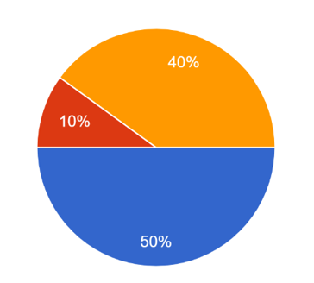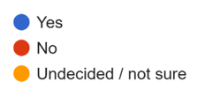

    - Means of contact
Respondents were clear in their desire to receive information through email – 95% indicated that they would like this method of communication for updates, AGM or other events or updates on nursing relevant content. This was followed by 35% who indicated the YNA website. 16-17% indicated Instagram or Facebook, with only 14% by text.
It is reasonable to consider communications using only email, however email + website would be a solid foundation.

